CHAPTER ONE
1.0 INTRODUCTION
The industrial training is a 6 months program officially supervised by the Industrial Training Fund (ITF) with funding provided by the federal government. This program is organized by the Student Industrial Work Experience Scheme (SIWES) in the tertiary institution.
In the course of this program students are empowered with practical knowledge of their various discipline which helps provide an avenue of acquired work experience in their field of study.
During this 6 months of industrial training. I was fortunate to be attached at Anambra State College Of Agriculture Mgbakwu (ANSCOAM) under the department of animal health and production supervised by Mr. C. U. Ezechi as the industrial based supervisor.
1.1 Brief History of Student Industrial Work Experience Scheme (SIWES)
Earlier in Nigeria, students from higher institutions of learning like universities, polytechnics, and college of education had no practice knowledge of their course of study. This possessed a lot of problem because these students had to go through series of training before they could have practical knowledge of their jobs.
Students Industrial Work Experience Scheme (SIWES) was introduced by the Federal Government of Nigeria to bridge the gap between theory and practice among products of our tertiary institutions. The scheme was first initiated and funded by the Industrial Training Fund (ITF) during the formative years 1973/1974.
1.2 Objectives of SIWES
S.I.W.E.S was introduced to;
- Provide skill acquisition.
- Provide placement in industries for students of higher institutions of learning approved by relevant regulating authority.
- Promote the desired technological knowledge required for the advancement.
- Prepare students for the work situation they will encounter after graduation
- Make transition from school to the labor market smooth and enhance students contact for later job placement.
- Expose students to work methods and techniques in the handling of equipment and machinery that may not be available in the universities.
1.3 History of ANSCOAM
The Anambra State College of Agriculture Mgbakwu (ANSCOAM) was established in 1979 by the defunct Anambra State Government as school of agriculture at Igbariam. Following the resource inspection visit by accreditation granted by NITSE was withdrawn 1989 as a result of the failure of the then state government to meet the required conditions for full accreditation of the institution. In 2007 the college was relocated from igbariam to the former site of Anambra State University which is now Chukwuemeka Odumegwu Ojukwu University campus.
1.4 ANSCOAM’s Farm Management Structure
The co-ordination of management of the farm is always under the Department of animal health and production. The head of department oversees the affairs of the farm as the general supervisor. The head of department has six supervising officers and a veterinary doctor working under him. These supervising officers coordinate the different section in the farm. These sections are piggery, poultry, small stock (micro livestock) and the fishery sections. The veterinary doctor monitors the medical state of the animals and administers drug to them. All the sections in the farm have attendants that feed the animals, clean the farm house and take record of activities like introduction of new animals, rate of growth, rate of production and reproduction.

1.4.1 Organogram of ANSCOAM farm

PROVOST
HOD (ANIMAL HEALTH AND PRODUCTION
VETERINARY DOCTOR
SUPERVISING OFFICERS
FARM ATTENDANTS
ANSCOAM STUDENTS
SIWES STUDENTS
EMPLOYED LABOURERS

Fig 1: Organogram of ANSCOAM farm

1.5 Objectives of ANSCOAM farm
- To provide income for the school
- To help the students practice what they are taught in the classroom
- To produce food for the society

1.6 Sections in ANSCOAM Farm

There are 5 sections in ANSCOAM farm they include;
- Piggery section.
- Fishery section.
- Rabbitry section.
- Ruminant section (goat and sheep).
- Poultry section

The system of farming practiced in this farm under these sections was intensive system of farming which involved rearing the animals in a suitable constructed house and being fed until they are ready for necessary use.

CHAPTER TWO
2.0 FISHERY SECTION
Fishery can be defined as the process involved in raising or harvesting either a species or different species of fishes either for feed, for commercial use or for any other purpose
Fishery section in ANSCOAM farm is the section where fishes were bred to mature stages. The species of fish reared in ANSCOAM farm was the Clarias gariepinus commonly known as the catfish. Sometimes, the farm cross-bred Clarias and Heterobranchus species to get a better hybrid.
Scientific Classification of Clarias gariepinus
Kingdom - Animalia
Phylum - Chordata
Class - Actinopterygii
Order - Siluriformes
Family - Clariidae
Genus - Clarias
Species - Clarias gariepinus

2.1 Description of Clarias gariepinus
Clarias species is recognized by their long based dorsal and anal fins, which gives them a rather eel-like appearance, they have slender bodies, a flat bony head, a broad terminal mouth with four pairs of barbells, they have a large accessory breathing organ composed of modified gill arches, they have a dark grey or black coloration on the back, fading to a white belly. C. gariepinus has an average adult length of 1-1.5m (3ft 3in – 4ft 11in) and reaches an average maximum length of 1.7m (5ft 7in) and can weigh up to 60kg but in ANSCOAM farm, the average length of an adult Clarias species is 1-1.03m and has an average weight of 3.2kg.
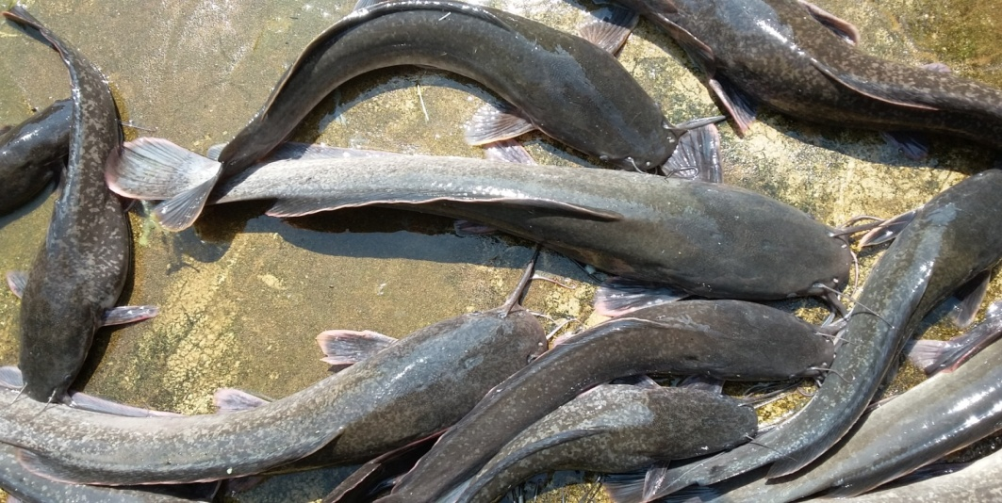

Plate 1: Clarias gariepinus

2.2 Methods of Fish Farming
Fish farming or fishery has 3 methods;
- One age culture: In this method, fishes of the same specie and age were brought together as fingerlings and raised to mature stages. One important advantage of this method is that it made harvesting easy. This was the major method practiced in ANSCOAM farm.
- Mixed culture: This is the traditional method of fish farming where fishes of different species and age were reared in the same pond at the same time. Harvesting in this method was very difficult.
- Monosex culture: In this method, fishes of the same gender were reared in one pond and another in the other pond.

2.3 Hatching
This is the process in which eggs were hatched under artificial conditions to produce young fishes and were reared either for consumption or for commercial purposes.
2.3.1 Reasons for hatching in ANSCOAM farm
The major reasons for hatching includes
- Generating income
- Teach the students in the institution
- Out of season production
- Genetic improvement
2.3.2 Hatching techniques
- The mature female catfish was injected with ovaprim injection in the evening.
- The next morning the female spawner was stripped of her eggs by gently pressing the abdomen with a thumb from the pectoral fin towards the genital papilla.
- The milt was got by killing a male fish and dissecting its testis.
- Few drops of the milt were added to the stripped eggs.
- A plastic spoon was used to mix the eggs and the milt.
- Physiological salt solution (NaCl) was added to the mixture to facilitate the mixing of the egg and milt.
- The fertilized eggs were incubated by a spreading them homogenously at 5ml/liter of water in a pond.
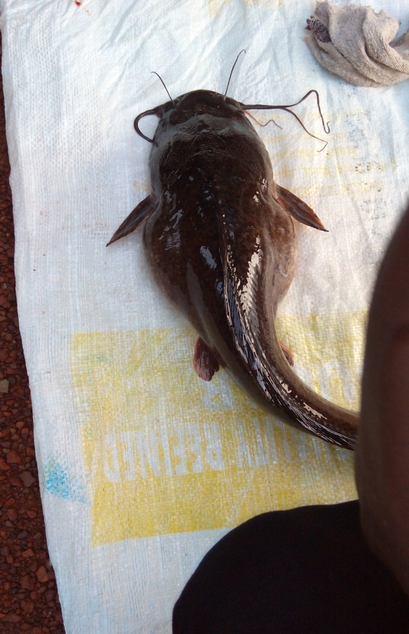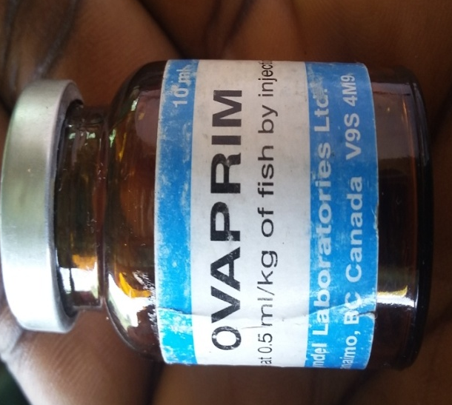
Plate 2: A mature female fish Plate 3: Ovaprim injection
2.4 Fish Breeding
These were the processes involved in rearing fishes after hatching from the young stage (fry) to the mature/adult stage. These processes involved changing water in the pond at intervals, control of weed and predation, reselection, fish feeding etc. Processes like fish preservation which involved salting, drying, etc for consumption purpose practiced by some other farms was not done here because the farm is managed by an institution under Anambra State Government which made most of their product for learning.
2.5 Fish Feeding
This is one of the most important aspect in fishery that determines ones success in fish farming. A good knowledge of this exercise is needed since the natural food available in the pond is not enough for the fast growth and maturation of the fishes within the expected period. In ANSCOAM farm, the feed mostly used in fishery section was the commercial feed produced by some companies specialized in producing fish feed (Top feed). Sometimes in the absence of commercial feed, we compounded feeds in the farm using some components in a required proportion depending on the type of feed to be produced.
2.5.1 Constitution of Feed
Below are the constituents or components used to compound or prepare fish feed in ANSCOAM farms
Protein
Plant Protein: Soya beans, Groundnut cake, etc
Animal Protein: Blood meal, Maggot meal, etc
Fish Protein: Fish meal, Fish innards, etc

Carbohydrates
Maize, rice, wheat, Millet, etc

Fats and Oil
Soya oil, Palm oil, Groundnut oil, etc
Supplements and Addictive
Vitamins, Minerals, etc

2.5.2 Qualities of a good Feed
A good feed as I was taught should be:
- Attractive and acceptable to the fishes
- Able to promote and assure fish growth
- Affordable and cost effective to the farmer
- Remain stable in the water for about 10mins

2.5.3 Types of fish feed
- Compounded fish feed: This is the type of feed commonly used in ANSCOAM farm. It was compounded from relevant ingredients based on some professional fish feed formula. The content and size of the fish pellet depended on the age and size of the fishes (powdered feed for fry, granular feed for fingerlings, pelleted feed for adult fishes). This compounded fish feeds includes both the one purchased in fish feed companies and the ones prepared in the farm.
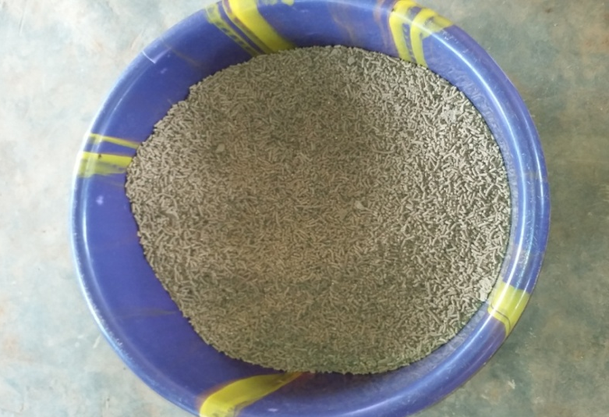
Plate 4: Pelleted feed for matured fishes
- Natural fish feed: This includes the algae and protozoa
- Live feed: this consist of maggots, tadpoles, earthworm, etc
- Agricultural waste: examples are poultry droppings (waste product), pig and cow dung.
2.5.4 Fish Diet
Fish diet was measured using Crude protein which is a term for the total protein content of a food source determined by its nitrogen content. The crude protein in fish diet ranges from 30% depending on the age of the fish.

Table 1: Fish feed size and the recommended crude protein content
Fish Size | Crude protein Content | Feed Size
Hatched fishes | 56-65% crude protein | 0.2mm-0.5mm
Fry/Fingerlings | 56-65% crude protein | 0.5mm-0.8mm
Juveniles | 42-45% crude protein | 3.0mm-4.5mm
Adult | 40-42% crude protein | 4.5mm-10mm
Brood stock | 30-35% crude protein | 6.0mm-10mm

As the fish matured, the content of the crude protein in their feed was reduced while the texture of the feed was increased.

2.5.5 Fish feed Production processes
Fish feed production involves the weighing, grinding, mixing of feed constituent and forming of feed ingredients to the size required for the fishes to feed on but in ANSCOAM farms, feed for the juveniles and mature fishes were produced while the ones for fry and newly hatched fishes were purchased.

Protein and non-protein contribution source
Milling
Mixing
Pelleting
Drying
Bagging
Fig. 2: fish feed production process
2.6 Fish Pond
A fish pond is a controlled pond, artificial lake, or reservoir that is stocked with fish used in aquaculture for farming, recreational fishing or for ornamental purposes.

In ANSCOAM farm, there were two types of ponds in the farm; the plastic ponds for the young fishes (fry, fingerlings and juvenile) and the concrete ponds for the mature fishes. Before hatching, the plastic ponds where the young fishes will be reared were washed, fumigated and sun dried for some days before filling it with water.
2.6.1 Features of a good fish pond
For maximum fish production, the fish pond must be in good condition. As I was taught in ANSCOAM farm, the qualities of a good fish pond include;
- The site chosen for the pond must have a suitable topography such that the fish farmer will be able to fill and drain the pond easily
- The pond should not be shallow
- The soil on which it is constructed should have a good proportion of clay in order to hold water (earthen ponds)
Plate 5: Plastic pond
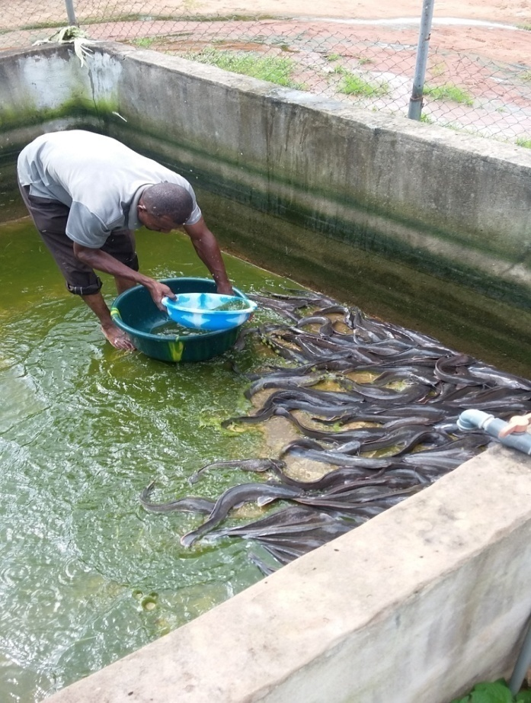
Plate 6: Concrete pond

2.7 Catfish Diseases
Diseases in fishes is one of the greatest problems faced in fishery and it is very important this diseases are prevented using necessary control measures so as not to decrease the fish production scale.
Common diseases found in fishes in ANSCOAM farm were;
1. Saprolegniasis: This is a diseases caused by Saprolegnia species. It developed in injured, weakened, diseased fishes. Signs of this disease include wooly-grey white or light brown batches on the skin, mouth, eyes or gills.
Treatment and Control;
A variety of chemical treatments were used to control the infection such as malachite green, copper sulphate, potassium permanganate, salt and formalin. Prevention involved maintaining the fish under good husbandry condition by correcting nutrition, ensuring good water quality, and avoiding overcrowding.

2. Infectious dropsy: It is also called ascites. It was caused by Aeromonas. Signs of this disease include red sores/streaks on the fish's body, distended abdomen, deformation of the backbone, and ulcers on the skin.
Treatment: Dead fishes were removed as soon as possible and burnt, epsom salt was added to the pond containing affected fishes.
3. Costiasis: It was caused by a protozoan parasite specie called Ichthyobodo necatrix. It attacked skin and gills of fishes causing lesions. Signs of this disease include; swollen gills, affected skin showing steel-gray discoloration, lethargy and respiratory distress.
Treatment: KMn0₄ or CuSO₄ was added to the water. Affected fish was dipped in a bath of 5-10% NaCl for 5-20 minutes daily for 1 week.

CHAPTER THREE
3.0 RABBIT SECTION
Rabbitry is a place where domestic rabbits are kept or reared either for consumption or for commercial purposes. The production of rabbit is also known as mini/micro livestock production while cuniculture is the agricultural practice of breeding and raising domestic rabbits, usually for their meat, fur or wool
In ANSCOAM farms, rabbits were reared both for commercial purposes and studies
Scientific classification of Rabbits
Kingdom - Animalia
Phylum - Chordata
Class - Mammalia
Order - Lagomorpha
Family - Leporidae
Genus - Oryctolagus
Species - Oryctolagus cuniculus

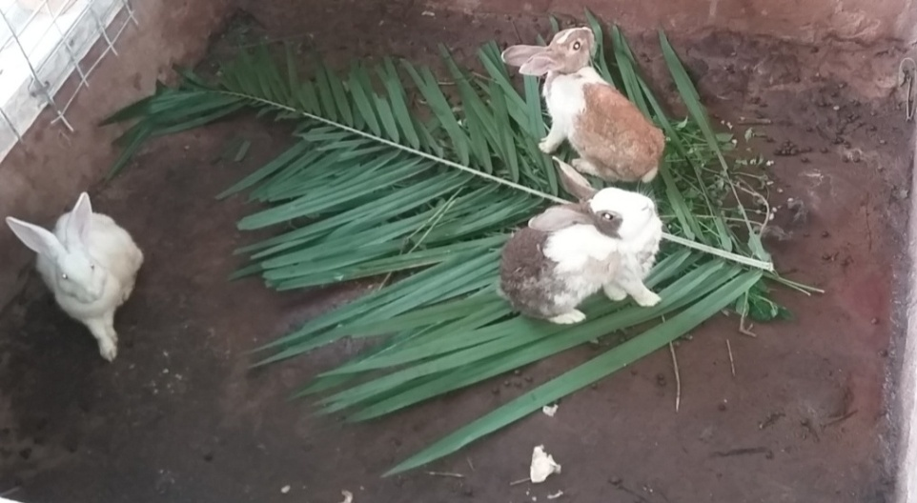
Plate 7: Rabbits in the hutches
In ANSCOAM farm, there were two breeds of rabbit;
- The New Zealand White
- The cross breed of California
Some terminologies in rabbit production
- Buck Male rabbit
- Doe Female rabbit
- Dam Mother of a particular rabbit
- Hutch Rabbit housing (where they are reared)
- Kindling The act of giving birth
- Litter Group of kits (young rabbits) born in one birth
- Rabbitry Place where rabbits are kept
- Sire Father of a particular rabbit
- Kits The young rabbit

3.1 Description
Rabbits are small, fury, mammal with long ears, short fluffy tails, and strong large hind legs. They have 2 pairs of sharp incisors, one pair on top and one pair at the bottom. They also have 2 peg teeth behind the top incisors. Their teeth are specifically adapted for gnawing and grow continuously throughout their lives. Rabbits vary in colour and size, ranging in weight from 2 to 16 pounds (1 to 7 kilograms), depending on breed.

3.2 Selection of Breed Stock
As I was taught, the selection of breed stock (buck and doe) is very much important aspect of breeding since good progeny is expected from good buck and doe. One has to consider the breeding stock in terms of fertility, maternal instinct, milk yield, growth rate, fecundity and viability.
Buck: A buck develops its breeding capabilities at the age of 8months. An ideal buck should maintain its reproductive ability at least 2 to 3 years. A young buck was allowed to mate one doe at an interval of 3 to 4 days. But from 12 months of age onwards it may mate 4 to 6 does in 7days. A buck at 6 years of age was culled since semen declines and in order to keep the buck healthy additional protein, vitamin and minerals were supplemented in diets
Doe: A doe should have the perfect ability to reproduce. A doe becomes capable to reproduce based on breed, nutritional status and seasons. The smaller breeds attain sexual maturity earlier than the larger breeds. A small breed may accept mating at 3 to 4 months of age whereas the large breed may accept mating at 8 to 9 months of age. A doe can be used for breeding up to the age of 3 years and culling should be made afterwards.
3.3 Feeding System
Rabbits feed mainly on hay or grass, some leafy greens (vegetables) and a measured amount of pellets. The nutritional need for rabbits varies depending on the stage of growth (age) and purpose for breeding the rabbits.

In ANSCOAM farms, rabbits were reared for studies and for commercial use and so they were fed with mostly pellets and sometimes vegetable and grasses from the environment. According to the stage of growth (age), the female rabbit (doe) in her lactating period needed the richest and most concentrated feed so as to breast feed the young ones. The kits (young rabbits) needed more amount of concentrated feed that will aid for their growth while the matured rabbits especially the bucks needed feed of average quality.

3.4 Reproduction
Reproduction in rabbits is between the buck and the doe.
3.4.1 Ovulation
The rabbits belong to a group of mammals that don’t ovulate spontaneously. There is no oestrus cycle. Sometimes females stimulate each other to the point of stimulation. This type of ovulation resulted in the female rabbits becoming pseudo pregnant or sterile for few days. Ovulation took place 10 hours following mating. Ovulation was also induced through mechanical stimulation of vagina
3.4.2 Mating
A Doe in heat showed some signs like restlessness, nervousness, rubbing of head and chin on the side of the cage or other objects. The vulva became swollen and purple in color. Acceptability of the doe to the buck or doe’s reaction to the buck was also taken as criteria for heat. The early hours of the morning and evening were the most conducive times for mating. The approximate age of first mating is 5 to 6 months of age.

3.4.3 Pregnancy
The gestation period in rabbit ranges from 28-32 days (approximately 30days). The nest box was kept within the cage to facilitate the doe for preparing bedding for the new born. The nest was provided at least 5-6 days before parturition. The nest box contained nesting materials like straw, grass, wood shaving, etc. Saw dust was not used as bedding materials. The doe pulled out her own hairs to make nest for litters. Adequate measures were taken concerning feeding and management during pregnancy period like giving the doe high quantity and quality of feed for 10 to 15 days of pregnancy, giving her plenty of fresh water and avoiding environmental stress as far as possible.
Pregnancy in rabbits was detected through the following ways;
- Palpation of abdomen by which embryos were felt by hand. This done at about two weeks after mating
- Placing the buck near the doe for mating. Bucks don’t mate pregnant ones.
- Changes in body weight

3.4.4 Kindling (parturition)
Process of giving birth of new baby in rabbit is known as kindling. It is a natural physiological phenomenon. The parturition very often took place at late night or early morning. It may not require any interference by the keeper.
The process was usually completed about 7-30 minutes. All the litters were not born on succession. Some kindled after several hours or a day depending on the species of rabbit involved. The pregnancy required to be terminated using injection of oxytocin. Following parturition the doe licked the young and ate the placenta. The doe was not disturbed during this time and were fed ad lilbitum. Adequate food and water were provided so that optimum amount of milk will be available to the baby rabbits. The doe nursed her young usually at night or early in the morning only for once. 6-12 kits were born from a single kindling. They were born naked but about 7days, there were growth of hair and vitality of them. The eyes opened after 10 days.

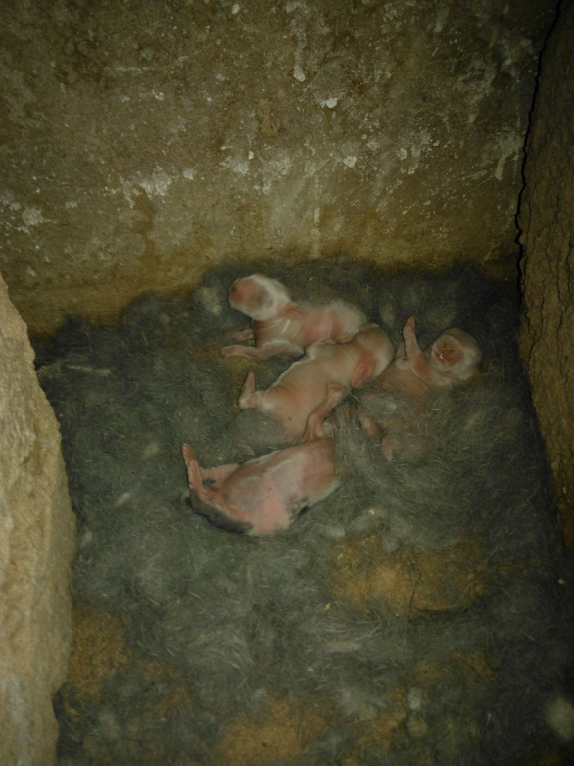
Plate 8: Litters in the hutch
3.4.5 Weaning
The kits were weaned after 21 days. The young was removed from their mother not before 4th week and this was done by removing the Doe from the cage and not vice versa. Foods like concentrates and grasses were provided. The Kits can chew and eat after 3 weeks of age. The Does can be rebred provided the physical conditions of them were satisfactory in nature after one week of kindling

3.5 Identification of Sex (Sexing)
Sexing was done at the time of weaning. To identify the sex the baby rabbit was placed on the hand and by the pressure of thumb and fore finger the sex organ was pushed on either side. In the case of Buck the penis came out as a protruded mass having rounded tip but a slit was located in case of Doe.

CHAPTER FOUR
4.0 PIGGERY SECTION
Piggery is a place in the farm where pigs are bred or kept. Pigs are non ruminant animals in the genus Sus that belongs to the family Suidae that are reared mainly for meat, pig skin, bristle and manure. In ANSCOAM farm, pigs were reared for studies and few times for meat and manure.
Scientific classification of pigs
Kingdom - Animalia
Phylum - Chordata
Class - Mammalia
Order - Artiodactyla
Family - Suidae
Genus - Sus
Species - Sus scrofa
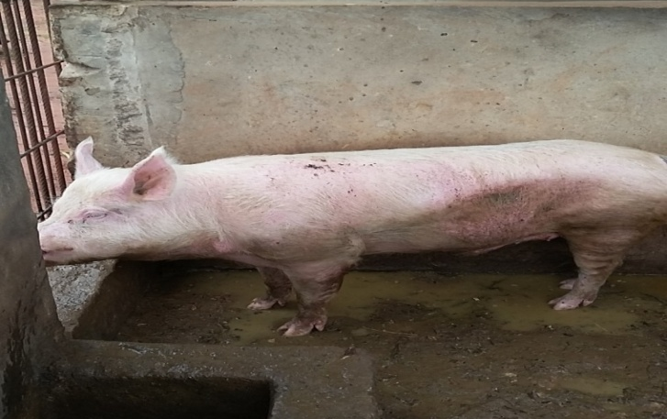
Plate 9: A mature boar
Terminologies used in Piggery
Boar : A mature male pig
Sow : A mature female pig
Gilt : A female pig that is matured to reproduce or has reproduced once
Piglet : The young or baby pig
Weaners : Young pigs just separated from the mother
Fatteners : Old pigs reared for the market
Barrow : A castrated male pig
In-sow : Pregnant sow
Dry sow : Sow that is not pregnant
Bulk : Pigs diet
Farrow : To give birth to piglets
Litter : All the offspring from a single farrowing

Breeds of Pig found in ASCOAM farm
- Large White
- Hampshire

Characteristics of Pig
- Pigs are prolific animals. At 8-9 months of age, gilt is matured and can farrow twice a year producing 8-10 piglets per litter.
- It has a short gestation period of 114 days (3months, 3 weeks and 3 days)
- They mature very early. A piglet gets to 60-90kg market weight in 6-9 months.
- Pigs are good converters of feed into meat. They can easily convert industrial, agricultural and compound feed into meat more cheaply and rapidly than most other domestic animals.
- Pigs require a very little investment in terms of building and equipment
- Pigs are polyestrous animal. This means they can be bred at any time of the year
- Pork is a good source of protein. It is high in energy, attractive, nutritious, tasty and tender

4.1 System of Rearing Pigs
There are three major systems of rearing pigs as I was taught. These are Extensive, semi-intensive and Intensive systems.
1. Extensive System: In this system, the pigs are allowed to roam about and fend for themselves. This system has little or no capital investment and the cost of production is low. However, disease incidence and worm infection is very high. The animals are exposed to adverse weather condition.
2. Semi-intensive system: In this system, housing is provided for the animals and they are allowed to move out to feed on natural vegetation. Paddocks are provided around the house which is fenced. Wallows and shades are also provided. The animals are allowed to move about thereby exercising themselves to prevent fat build up in the body. This system needs less capital investment but the labour, disease incidence and parasite infestations are slightly high.
3. Intensive System: All the pigs are confined within a building and are not allowed to move out in this system. The pigs are raised inside the pens on either concrete or iron slate floor. Feeds, water and medication are supplied daily in adequate quantity and good sanitation is maintained. This system saves labor and prevents infestation of parasites. There is also protection from extremes of climate, predators and thieves. The feed efficiency is high, thus, the growth rate is also high. This system requires high capital investment in terms of building and feeding.
In ANSCOAM farm, intensive system of rearing pigs was practiced which helped us to study, know and also understanding the processes involved in rearing pigs.
4.2 Housing
Pig houses are sheds that provide shelter against harsh weather as well as proper hygienic conditions required to maintain healthy growth of animals. There are so many ways of constructing pig house depending on the stages of production of pigs, the available resources, the preference of the farmer and the location.
Factors to consider when constructing house for pig
Before constructing a pig house, certain factors are to be considered. These factors as I was taught include;
- Pig house should be constructed along the direction of the wind but should be far from residential areas.
- It should have low walls made of bricks, stones and concrete cement with low walls to allow free flow of air
- The floor should be hard, impervious to water but easy to clean
- The floor should slope towards the drain with a gradient of 1:40, to ease cleaning. The surface of the floor should be slightly rough to prevent the pigs from slippering.
- The roof should be made of either asbestos, galvanized iron or aluminium sheets.
4.3 Feeding
Pigs are omnivorous, which means they can consume both plants and animals. One of the best foods considered for pigs is the corn as it is a good source of digestible carbohydrates and contains less fiber. Apart from that pigs like to feed on corn, they can also be fed with soya bean meal, hay, and vegetables, like carrots and potatoes.
In ANSCOAM farm, the pigs kept in the pen were fed with over stayed bread from bakery, peels of cassava and yam, paw-paw fruit and leaf, Gmelina leaves, weak infected fishes from the fish ponds and animals used for practicals.

4.4 Reproduction and sexual maturity in pigs
Pigs are highly prolific in nature and they attain maturity stage very fast. A young boar becomes sexually matured within 6-7 months of age while the sow reaches 8-9 months of age to attain maturity. Gestation period last for 114 days and a mature sow farrows twice a year.

Factors affecting reproduction
- Feeding regime
- Health status
- Management practices
- Environmental factors
4.5 Care of Piglets
Piglets need to be taken good care of to prevent piglet mortality. The following was done to the piglets in ANSCOAM farm from birth.

4.5.1 Birth to weaning:
i) When the piglets were born, the mucus membrane was wiped from their nose to prevent suffocation.
ii) The naval cord was cut and dipped in iodine solution to prevent infection.
iii) Heat was provided for the piglets to prevent stress due to cold.
iv) The needle teeth of the piglets were clipped or cut off to prevent injury to mother’s teat and piglets during fighting.
v) The piglets were given first dose of iron dextran injection at 2 or3 days of birth and the second dose 2 or 3 weeks later to prevent pig anemia.
vi) Creep feeding started at about 2 weeks after farrowing. Creep feed is high in protein (22%) and other nutrients. It supplements milk in-take from the snow and also aids the growth of the piglets and their early weaning.
vii) They were weaned (separated from their mother) at 42 days or 6 weeks of age.

4.5.2 Weaning to finishing (market size)
- Weaners were transferred to the growing or fattener’s house
- The pigs were fed on the weaner’s mash and later changed to fattener’s mash few weeks later.
- Vaccines and drugs were administered to the pigs to prevent diseases.
- Parasitic infection was prevented through regular de-worming and spraying of pigs with insecticides.
- Wallows where pigs cool down their body temperature were provided because they are non-sweating animals.
Pigs, now fatteners reach market age when they were about 5-6 months old depending on the level of nutrition and management as well as the species
4.6 Common Diseases of Pigs
Common diseases of pigs include: brucellosis, anthrax, swine erysipelas, hog cholera or swine fever, pleuropneumonia, enteritis or swine dysentery, transmissible gastro-enteritis, etc

1. Brucellosis or Contagious Abortion
This disease is caused by a bacterium called Brucella abortus. Symptoms include high fever, diarrhea and dysentery, posterior paralysis and premature abortions. The disease was transmitted through contaminated feed, water and infected animal. Control measures include isolation of infected animals, proper sanitation and regular vaccination.

2. Anthrax
This disease is caused by a bacterium and transmitted through contaminated feed, water, equipment and infected animals. Symptoms include high fever, depression, blood oozing from nose, mouth, anus, or carcass, lack of appetite and sudden death. The disease was controlled by proper sanitation, vaccination and isolation of infected animals.
3. Enteritis or Swine Dysentery
This is a bacterial disease that causes serious digestive tract disorder. It is caused by a spirochaetal bacterium called Brachyspira hyodysenteriae. Symptoms include high temperature, loss of appetite, foul smelling faeces (which may be bloody) and loss of weight. Control measures included the administration of sulphur drugs and antibiotics such as terramycin and aureomycin.
4. Hog Cholera or Swine Fever
This disease is caused by a virus. It affects pigs of all ages and the infectious agent responsible is the Hog Cholera virus or Classical swine fever virus of the family Pestivirius. Symptoms include high body temperature, diarrhea and vomiting. The only control measure was to kill the infected animal and bury them.
5. Transmissible Gastro-enteritis
This is disease is caused by a bacterium and attacks piglets mostly. Symptoms include diarrhea, vomiting, and sudden death. The faeces of affected piglets are usually white or green in colour. Antibiotics and sulphonamide drugs were used to cure the disease.
.
CHAPTER FIVE
5.0 RUMINANT SECTION
This section in ANSCOAM farm is the section where ruminant animals (goat and sheep) were bred.
5.1 Goat Farming
Goat farming is the process goats are reared for production of meat, milk or any other commercial purposes. In ANSCOAM farm, the breed of goat reared is the African black goat. They were reared for both the production of meat and basically for studies.
Scientific Classification of Goats
Kingdom - Animalia
Phylum - Chordata
Class - Mammalia
Order - Artiodactyla
Family - Bovidae
Genus - Capra
Species - Capra aegagrus
5.1.1 Description
Goats are hollow horned small ruminant animals. Both sexes have beard in their adult stage. Their skin colour most times is usually black, brown, white or a combination of these. Goats have horizontal, slit-shaped pupils.
Some terminologies used in Goat
Plate 10: African black goat

Billy (buck) --- Adult male goat
Doe (nanny) --- Adult female goat
Kid --- A young goat
Buckling --- Baby male goat
Chevon --- Goat meat
Disbudding --- The practice of removing horns on a goat
Doeling --- Baby female goat
Kidding --- Having babies
Wether --- Castrated male

5.1.2 Rearing System
The rearing system used in ANSCOAM farm was the intensive system. This system has to do with rearing goats in a pen to protect them from adverse conditions like heat, cold, rain. These pens were swept every morning.
.
5.1.3 Feeding
Goats are herbivorous animals. They feed on grasses, shrubs, vegetables, other food sources like yam, and fruits like avocado peer and peeled oranges. In ANSCOAM farm, the goats were fed mainly with leaves such as palm leaves and gmelina leaves. They were also fed with peeled oranges, peeled peer and spoilt avocado peer.
5.1.4 Reproduction
Goats reach puberty from 4 months. Heat period occurred every 21 days with some courtship behavior display such as flagging of the tail, staying near the doe, becoming more vocal and lack of appetite. Sometimes the billy urinates on its body to add to its odour and this made the billy more attractive to the doe. Gestation period is between 145 - 154 days. Goats give birth to two kids in each kidding but some give birth to just one.
5.1.5 Common Goat Diseases
Common disease encountered in goat farming includes Anthrax, brucellosis, rinder-pest, red water fever, etc. Drugs and vaccines were always administered at the proper time in order to prevent the disease outbreak.

5.2 Sheep Farming
Sheep farming is the rearing of sheep in a farm either for the production of meat or for commercial purposes. In ANSCOAM farm, the breed of sheep reared was the balani specie. They were reared majorly for studies and sometimes for production of meat.
Scientific classification of sheep
Kingdom - Animalia
Phylum - Chordata
Class - Mammalia
Order - Artiodactyla
Family - Bovidae
Genus - Ovis
Species - Ovis aries
5.2.1 Description
Sheep are ruminant animal with short tail that hangs downwards. Body covered with an outer coat made of wool. Some breeds don’t have horn while most breeds have a single pair but a few may have several. Their rate of growth and mature weight is a heritable trait that is often selected for in breeding; ewes typically weigh between 45 and 100kg and rams weigh between 45 and 160kg. A mature sheep has 32 teeth. Sheep have good hearing and are sensitive to noise when being handled.

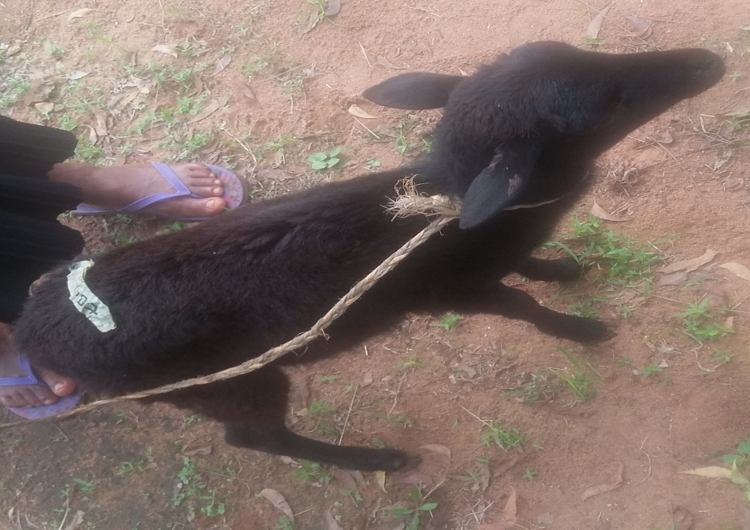
Plate 11: A balani sheep
Terminologies in Sheep farming
Ram(tup) : Adult male sheep
Ewe (yow) : Adult female sheep that has given birth to 2 sets of lamb or more
Gimmer : A female sheep
Hogg : A young sheep that has just finished weaning
Lamb : A young sheep that is not yet weaned
Wether : A castrated male sheep
Lambing : The process of giving birth
5.2.2 Feeding
Sheep are herbivorous animals. Most breeds prefer to feed majorly on grasses. But in ANSCOAM farm, this section practiced semi intensive system of rearing. Sometimes the sheep were allowed to graze freely on grassland and later in the evening, they were returned to their pen while some times we fed them in their pen with either gmelina leafs or palm leafs.
5.2.3 Reproduction
Most sheep are seasonal breeders, although some are able to breed year round. Ewes reach sexual maturity level at 6 to 8 months while that of ram is 4 to 6 months. Gestation period last for about 5 months and may give birth to one or two lambs depending on the breed but throughout my stay in ANSCOAM farm, I did not witness sheep reproduction.
5.2.4 Health Care and Sanitation
Common routine measures that were adopted for sheep health care and sanitation include:
- The sheep pen and stall were washed and cleaned daily
- Sick animals were isolated and treated
- Dead animals were buried
- Sheep were de-wormed on daily basis
- The environment was kept clean and dry at all time
5.2.5 Diseases
Common disease of sheep include: Anthrax, brucellosis, rinderpest, red water fever, etc.

CHAPTER SIX
6.0 POULTRY SECTION
Poultry is mostly concerned with the rearing and taking care of domestic birds for the production of meat and eggs. It can be defined as those species of birds that render economic services to man and reproduce freely under his care. It includes birds such as chicken, ducks, turkey, pigeon, quail, etc.
In ANSCOAM farms, layers and broilers were reared using the intensive system of rearing. These 2 sets of chicken were reared for production of meat, eggs, and for studies. The breed of chicken reared in ANSCOAM farms is the domestic fowl (Gallus gallus domesticus).
Scientific classification of domestic fowl
Kingdom Animalia
Phylum Chordata
Class Aves
Order Galliformes
Family Phasianidae
Genus Gallus
Species Gallus domestica
Terminologies in poultry production
Hen : a matured female chicken generally above 20 weeks of age
Cock : a matured male chicken above 20 weeks of age
Pullet: a young female chicken from 9 to 20 weeks of age
Cockerel: a young male chicken from 5-8 months of age
Chick: a young male or female fowl below 5 weeks of age
Grower: a young chick of 9th to 20th week of age of either sex
Brood: a group of chick of same age raised in one batch
Broiler: hybrid chicks having rapid growth and attaining about 1.5kg weight within the period of 6 weeks
Capon: a young male bird of which testicles are removed
Layer: an egg laying female chicken up to one year after starting the laying of eggs
Importance/Benefits of Poultry
- Source of food
- Source of income/revenue
- Source of employment
- Production of manure
- Used as sacrifice to gods
- Some people keep poultry for prestige in relation to how wealthy they are.
6.1 Branches of Poultry
- Egg production: In ANSCOAM farm, this is branch of poultry that dealt with the production of hatchable eggs or table eggs. The hatchable eggs were produced when cocks were allowed to run with the hen for mating and thus there was production of fertilized eggs. Table eggs were produced from the class of poultry that produces eggs without mating.
- Production of day old chicks: This branch of poultry is involved in the production of new chicks from the hatchable eggs. Good quality hatchable eggs were required to produce quality day-old chicks. It is important to note that day-old chicks should be sourced from a disease free hatchery. The first step towards successful poultry farming is obtaining high quality day-old chicks.
- Broiler Production: This is the branch of poultry which deals with the production of meat type birds instead of eggs. Broiler chicks were sourced from a reputable hatchery and managed for 6-10 weeks to attain weight of between 1.8-2.5kg. Cockerel chicks are also used to produce meat though they require more time when compared to broilers attaining slaughter size between 16-20 weeks.
- Allied Branches of Poultry Production: Apart from production of meat and egg, there are other allied branches of poultry include equipment manufacturing, feed milling industry, feed ingredients supply, drug manufacturing industries, manure production, etc.
6.2 Poultry House
The construction of poultry pen depends mainly on the type of poultry a farmer decides to venture into (turkey, broiler or breeder production), if the venture is intended for eggs or meat production, the type of production system to be considered (deep litter or battery cage system).

As I was taught, the following characteristics should be considered when constructing poultry houses:
- The poultry pen must give adequate production against predators like snake, soldier ants, etc
- Ventilation must be adequate
- The material to be used must be durable
- The house must be spacious
Material that are needed for constructions are:
- Brick (made from cement or clay)
- Cement
- Sand and gravel
- Roofing materials like corrugated iron sheets, asbestos or aluminium sheets
- Wire mesh
- Planks
- Nails
The following are the factors that should be considered when selecting sites and constructing pens for poultry:
- Topography
- Avoid water logged area
- Nearness to the residential area
- Security
- Electricity supply
- Accessibility

6.2.1 Management and housing systems
The different management and housing systems in poultry are summarized below:
Management system; Housing system
●Extensive system ●Range system
●Intensive system ●Deep litter system
●Wire and slatted floor system
●Battery cage system
In terms of management systems, the one practiced in ANSCOAM farms is the intensive system and the housing system used in this same section is the deep litter housing system and the battery cage housing system
The deep litter system: This consists of a fixed building having suitable litter material spread on the floor. A windowless house, with provision for environmental control is used in temperate region but an open sided house is used in the tropics. The roof of a poultry house may be full-span or lean to. Lean-to roofs may create problems of rain drifting into the house. With all types of roofs, the eaves should be long enough to check the rain. The floor of the house is usually divided into pens along the length and if sufficiently wide, there should be central passage running the length of the house. A store may be situated at the end of the house, but should preferably be a separate building and there should be 2 stores, one for the egg and one for the feed.
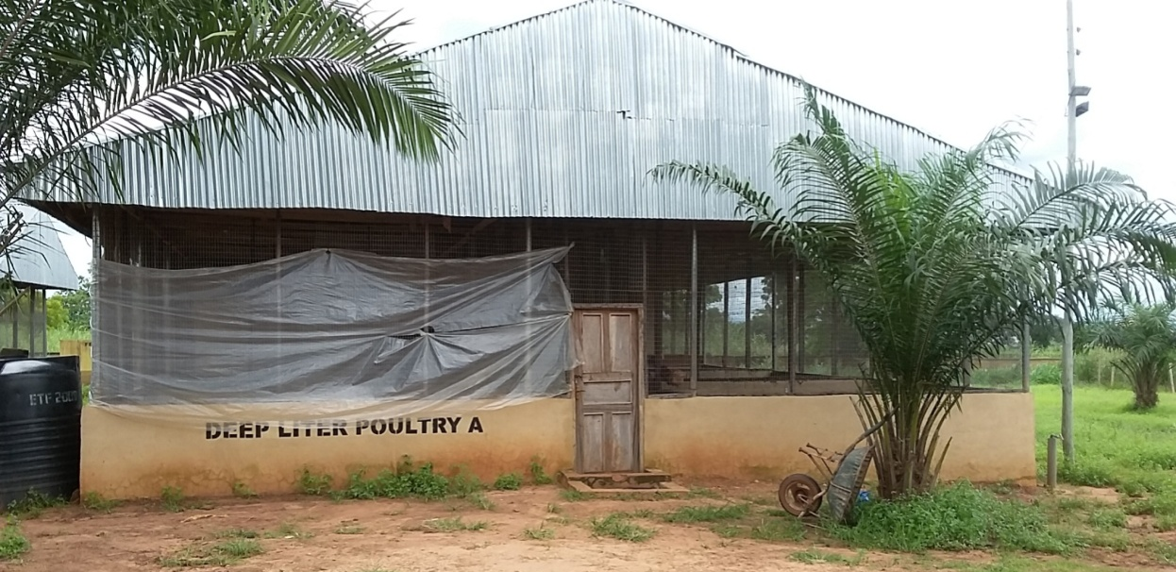
Plate 12: The deep litter housing
The Battery Cage System: This system appears structurally close to the wire floor than any other housing system under the intensive system of management. In this cage system, the birds are housed in individual compartments, each accommodating a limited number of birds, mostly one or two. The individual cage compartment is the basic component unit of the cage system and it is essentially a laying nest with a sloping floor, feed and water troughs. It is usually constructed to permit ventilation form all sides. Usually the sides top and the floor are constructed heavily with galvanized iron and the sloping floor extends forward and folds gently to form the cradle from which the eggs are collected.
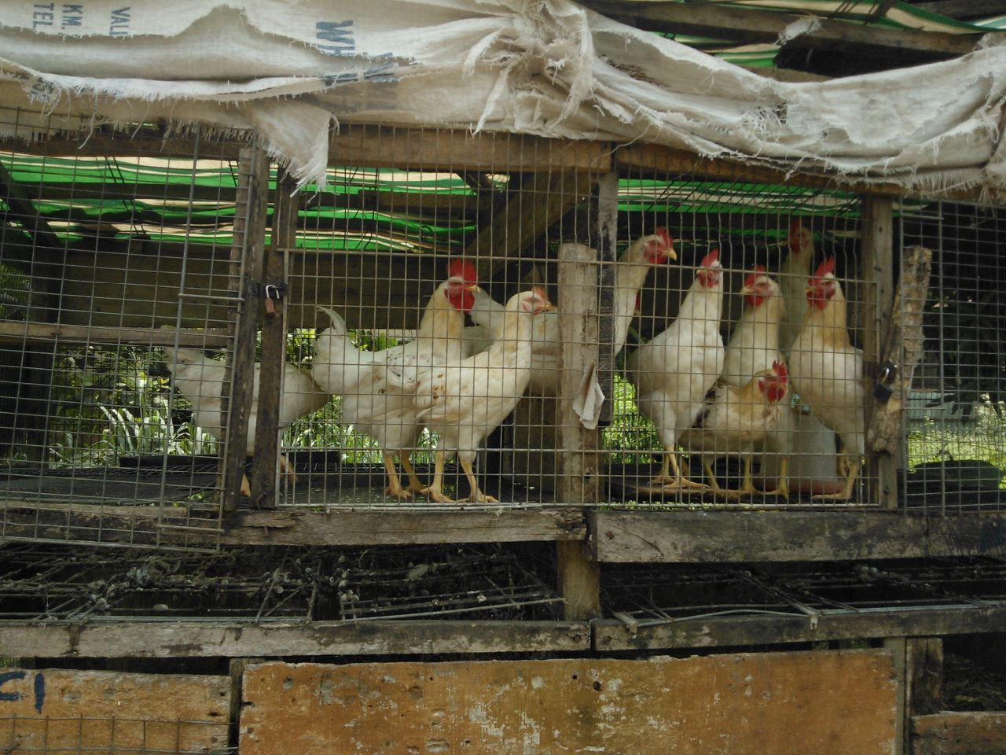
Plate 13: birds in the battery cage housing system
In ANSCOAM farms the layers were reared only in the deep litter housing system while the broilers and the cockerels were reared both in the deep litter and battery cage housing system.
6.2.2 How to reduce thermal stress in the poultry house
Several measures have been investigated and some are being adopted as ways of reducing thermal stress in poultry. Among these are;
- Insulation of roofs
- Installation of fans
- Painting the roof with reflective roof paint
- Installation of internal air misters
6.3 Chick Management
Chicks were bought from a reputable hatchery or a reputable chick dealer that has good breed of chicken free from disease. Several factors were put in mind before placing orders for chicks and these include;
- Purpose of keeping birds
- Number of chicks needed
- Livability
- Age at sexual maturity
- Egg laying ability
- Colour and size of eggs
- Resistance to disease, parasite and other stresses
- Shape and size
- Feed consumption rate
- Body conformation at maturity
Between the chicks were collected from the hatchery and the time they are sent for brooding on farm, the following operation were performed;
- Inspection
- Transportation
- Delivery
6.3.1 Brooder house
The house was located at least 100m away from adult birds to reduce danger of disease transmission. It was located in such a way that air current moves from brooder house to adult birds and not the other way round. The arrangement entailed providing a separate house for brooding especially where it involved large number of chicks. The preparation for brooding chicks started about two weeks before the chicks were received. Two days before the chicks were received the floor was covered with wood shaven to depth of 5cm on a concrete floor.
An equipment peculiar to the management of chick was the brooder. This is a complex unit consisting of the heater, drinkers, feeders and a surround or a guard.. This canopy reflects heat back to the chicks and it was kept clean on the under surface.
Heating media for the brooding are those materials that act as the source of heat in brooding chicks and they include;
- Electricity
- Paraffin or kerosene
- Propane gas or domestic cooking gas
- Coal or charcoal in coal pot
- Stove
- Lamp
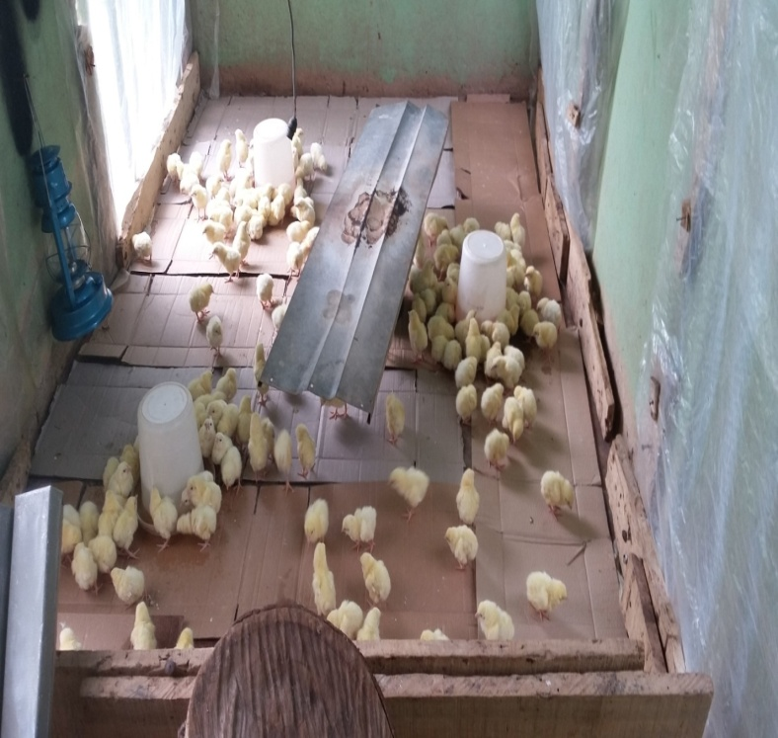
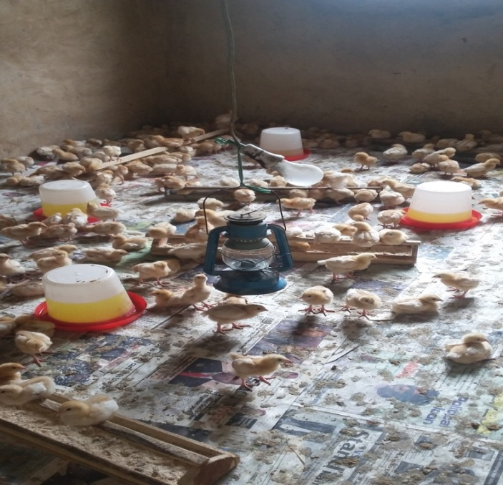
Plate 14: Brooding house for layers Plate 15: Brooding house for broilers
6.3.2 Brooding
This is the care of chicks from a day old to 6 weeks of age. It consists primarily of the provision of heat, air water and feed. It is the efficient combination of these factors that determine the level of physical and physiological development and mortality of the chicks. The mortality of the chicks during this period should normally not exceed 5%. Chicks can be naturally brooded by the mother (hen) or artificial which entails the use of special appliances that supply heat.
6.3.3 Practices in brooding
Two main practices were done during brooding and they are; routine and occasional practices.
Routine practice: It involved;
- Daily observation of the birds.
- Provision of clean water and feed once or twice daily except where the system is automated.
- Sanitation practices which include washing drinkers daily, keeping the passage within the pen neat by sweeping, removing spider webs from the ceiling, renewing and toping of disinfectant solution in the foot dip.
- Daily record keeping
Occasional practices: It involved;
- Extension and removal of brooder guards.
- Reduction and removal of litter.
- Change of tray feeders to bigger ones after one week and drinker after 4 weeks.
- De-beaking.
- De-worming.
- Medication.
- Culling.
- Vaccination.
6.4 Management of Growers
Chicken between 8-20 weeks of age are referred to as growers. They are not as delicate as chicks and they are not as important as layers. Certain precautions were taken during this stage to ensure their proper growth. They include;
- Every grower was provided a feeder space of 7.5-10cm. This space enables all the growing pullets to eat at the same time when feed is served. Drinker space is less than feeder space because birds spend less time drinking than eating.
- They were fed with grower mash within the age of 8-20 weeks.
- The routine management practices done during this stage were; provision of adequate feed regularly, washing the drinkers daily, keeping daily record, de-beaking 10-12 weeks especially when pecking was noticed, and providing prophylactic treatment against coccidiosis.
6.5 Management of Layers
Adequate management of layers leads to maximum egg production provided that the occurrence of disease, parasite and mortality are minimized. It also leads to high economic return with a corresponding high prospect of expansion.
6.5.1 Preparation before laying
Preparation started from the 16th week and included the following;
- Vaccination, de-beaking and de-worming.
- Transfer of pullets to the laying house or cages between 16-18 weeks and not later to prevent stress
- Change of litter if birds were not to be moved to another laying house or cages
- Supplementary lighting, etc
6.5.2 Feeding in layers
Layers were fed in 3 phases which includes: chick mash (0-8 weeks), Grower mash (8-20 weeks), layers mash (above 20 weeks). Layers mash was fed to the birds after 5% egg production. When pullet started laying they eat much because they were simultaneously growing in size. After 30 weeks of age, body growth rate reduced and most of the feed were used for egg production.
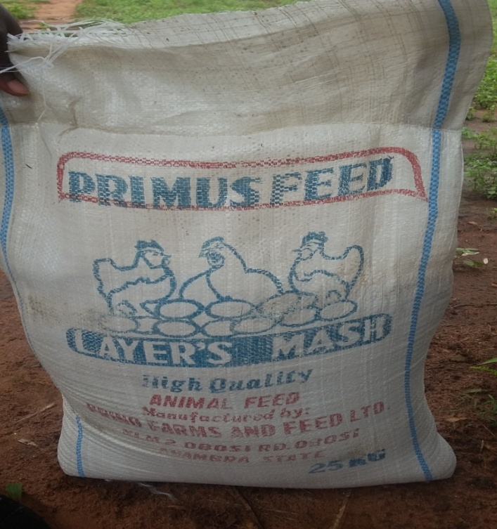
Plate 16: Layers feed
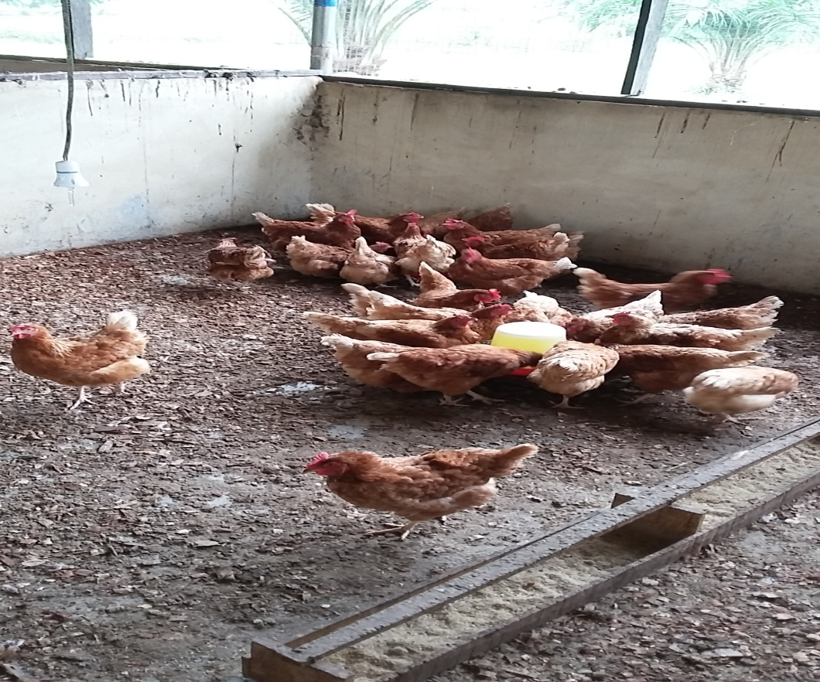
Plate 17: Layer feeding in a pen
6.5.3 De-beaking
This consist of the partial removal of the beak to prevent vice habits including pecking and feather pulling, cannibalism, and egg eating depending on the age when they occur. De-beaking was done in layers before 16th week of age because it was close to the laying time.
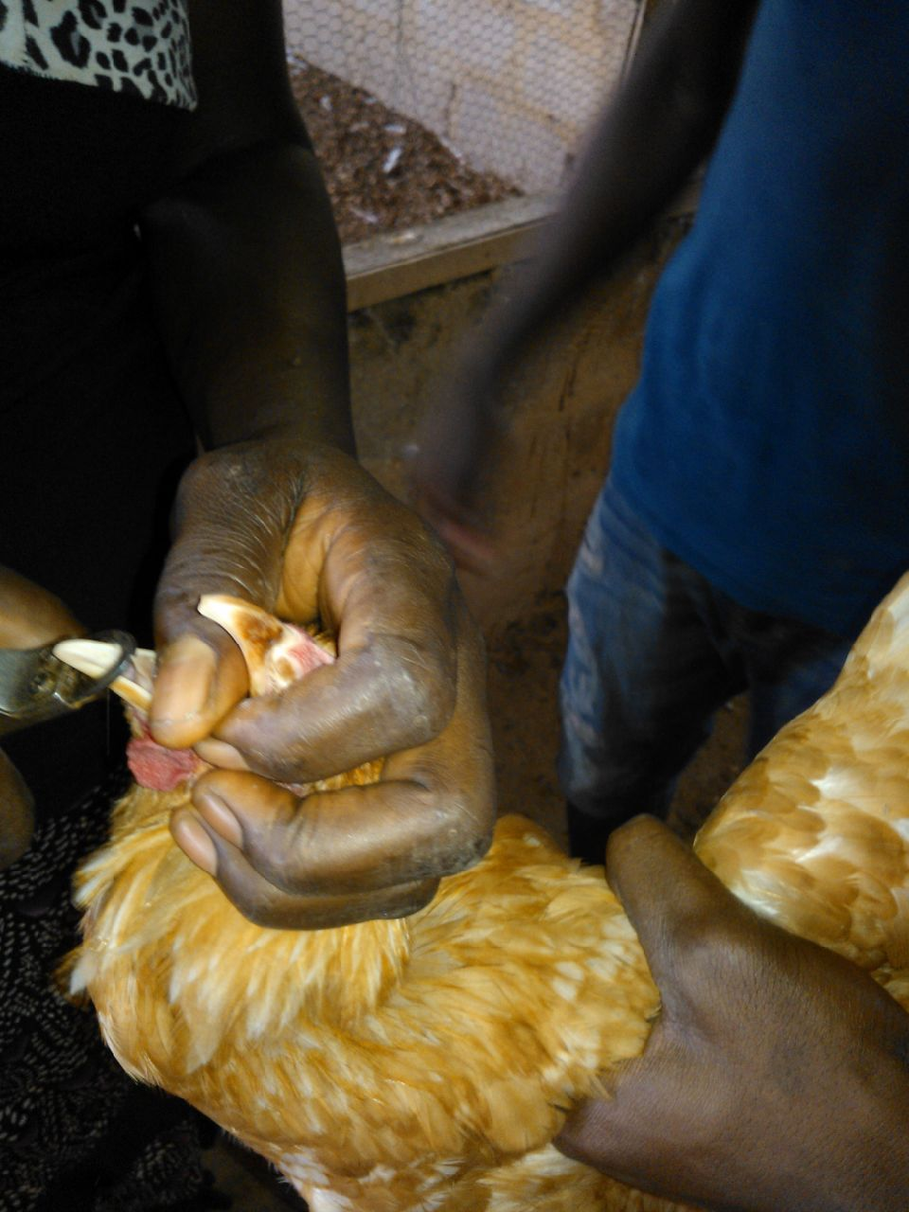
Plate 18: De-beaking of layer birds
6.5.4 Egg production and Egg Laying Pattern
Most layers dropped their first egg at the 5th month of age (20-23 weeks). Most layers reached peak production within 8-10 weeks of lay (28-33 weeks). Many layers remained on this peak of 80-90% hen day production for 5-6 months with very little depression if any. It is a good practice to collect egg at least a day on the floor. If the eggs were left uncollected, the hen broke them in the process of laying or deliberately cracked and ate some of them. Collecting the eggs 3-4 times daily is the best.
6.5.5 Factors affecting laying performance
- Age
- Stress
- Disease and parasite
- Poor nutrition
- Breed of layers (genetics)
- Poor management
- Infrequent egg control
- 6h Inadequate floor space, drinkers, feeders, poor ventilation and poor lighting
6.6 Management of Broilers
Broilers are domestic fowl bred only for the production of meat. Adequate management of this breed of domesticated fowl will lead to maximum and production of meat both for sell and for consumption.
6.6.1 Broiler rearing program
There are three rearing programs adapted for broilers as I was taught. These include;
- Occasional rearing for specific events such as Easter, Christmas, sallah festival, wedding anniversary, etc
- Regular rearing program
- Multiple rearing program
In ANSCOAM farms the rearing program adopted for broilers was majorly multiple rearing program although occasional rearing program was also applied.
6.6.2 Feeding
Broilers can be fed on the same diet from day old to market age if the diet is adequate in protein and energy. They are commonly given mash but crumbles and pellets are also acceptable to them. Nutritional requirement of broilers vary in age, hence 2 different diets were commonly given to broilers.
- Broilers start diet (starter): This contains 22-24% crude protein and 3190cal/kg energy. This was fed to the broilers for the first 4 weeks.
- Broilers finish diet (finisher): This contains 20-21% crude protein and 3300cal/kg of energy. This was fed after 4 weeks of age till market age (8-10 weeks).
In ANSCOAM farms broilers were fed with starter feed as explained above and also finishers feed from 4 weeks of age to market size. The same pattern of brooding in other chicks like layers was also applicable to the broilers in the farm. The only difference was that the period of brooding only takes place for 2-3 weeks especially during warm weather for the broilers because they grow fast.
6.6.3 Feed Preparation
Feed preparation is one of the most important practices in poultry. Sometimes there may be absent of commercial feed gotten from the market or maybe not enough money to purchase them. In ANSCOAM farms feed preparation or self milling was a common routine which really enhanced the production of both meat and egg in poultry farming. There were factors considered before embarking on feed preparation. They include;
- The nutrient requirement of the particular birds to feed
- Ingredients that were available easily and cheaply
- Nutrients composition of each ingredient
- Constraints of each ingredients
- Accessibility to milling facilities
Nutrients and common sources
Carbohydrate e.g Maize, Sorghum, wheat, cassava, etc
Fats e.g Palm oil, animal fat, tallow, etc
Protein: Animal protein e.g fish meal, blood meal, meat and bone meal, shrimp meal, etc
Vegetable protein e.g soya bean meal, groundnut cake, cotton seed, cake, etc
Vitamins: Both fat soluble vitamin and water soluble vitamin are usually added to premix
Minerals: e.g salt and other minerals are added to premix except for calcium and phosphorus
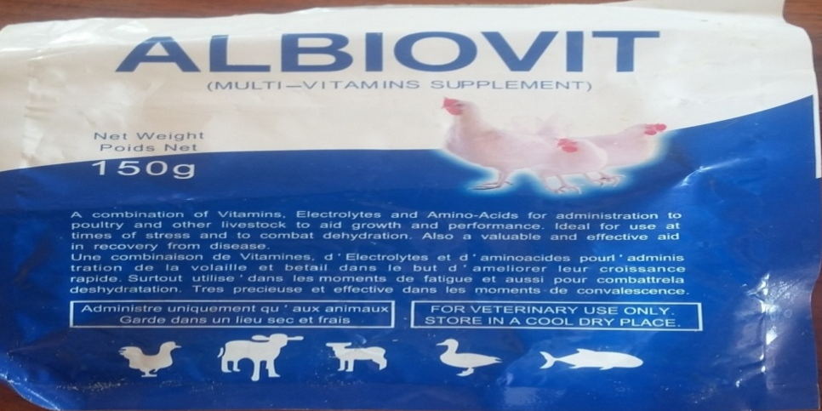
Plate 19: Multi-vitamin for poultry feed
6.7 Vaccination
Vaccination also known as immunization is the administration of vaccine to stimulate the immune system of an animal in order to produce specific antibodies against viral, bacteria, fungi and protozoan diseases. It is a protective device used to prevent the outbreak of many poultry diseases if is well done.
Vaccines are biological capable of stimulating immune response towards the production of antibodies. It confers immunity upon flocks over a specific period of time.
6.7.1 Types of Vaccines
There were different types of vaccines used in ANSCOAM farm. Based on the mode of action or how they work, they are categorized into;
- Attenuated live vaccines: This contain a modified live disease causing agent or antigen usually adapted from the field for administration either individually (mareks disease vaccine, fowl pox vaccines, etc) or by mass application (HB1 vaccine, Gumboro, lasota vaccines).
- Killed or inactivated vaccines: This was mostly used. It is oil emulsion based. The antigen is suspended in the oil e.g. ND+EDS oil vaccine, ND+IBD oil vaccine, etc.
6.7.2 Vaccine administration
In ANSCOAM farms there are several ways vaccines were administered. They include
- Oral or drinking water administration
- Aerosol administration
- Eye drop and inter-nasal route
- Parentheral vaccination which includes subcutaneous and intra muscular injection.
6.7.3 Vaccination schedules
The vaccination schedules in poultry production include the following:
Table 2: Broilers Vaccination Schedule
AGE | VACCINATION | ROUTE
Day old | New castle Disease Vaccine | Intra-ocular
3-7 days | Gumboro vaccines | Oral
8-10 days | Lasota | Oral
14-18 days | Gumboro booster | Oral
28-30 days | Lasota booster | Oral

Table 3: Layers Vaccination Schedule
AGE | VACCINATION | ROUTE
Day old | Mareks | Intra muscular
Day old | New Castle Disease Vaccine | Intra ocular
Day 10 | Gumboro | Oral
Day 18 | Gumboro | Oral
Day 28 | Lasota booster | Oral
Day 40 | Gumboro (optional) | Oral
Day 56 | NDV Kamorov | Intra muscular
Day 70 | Fowl pox | Wing web
Day 112 | NDVK (booster) | Intra muscular
Day 126 | Egg drop syndrome vaccine | Intra muscular

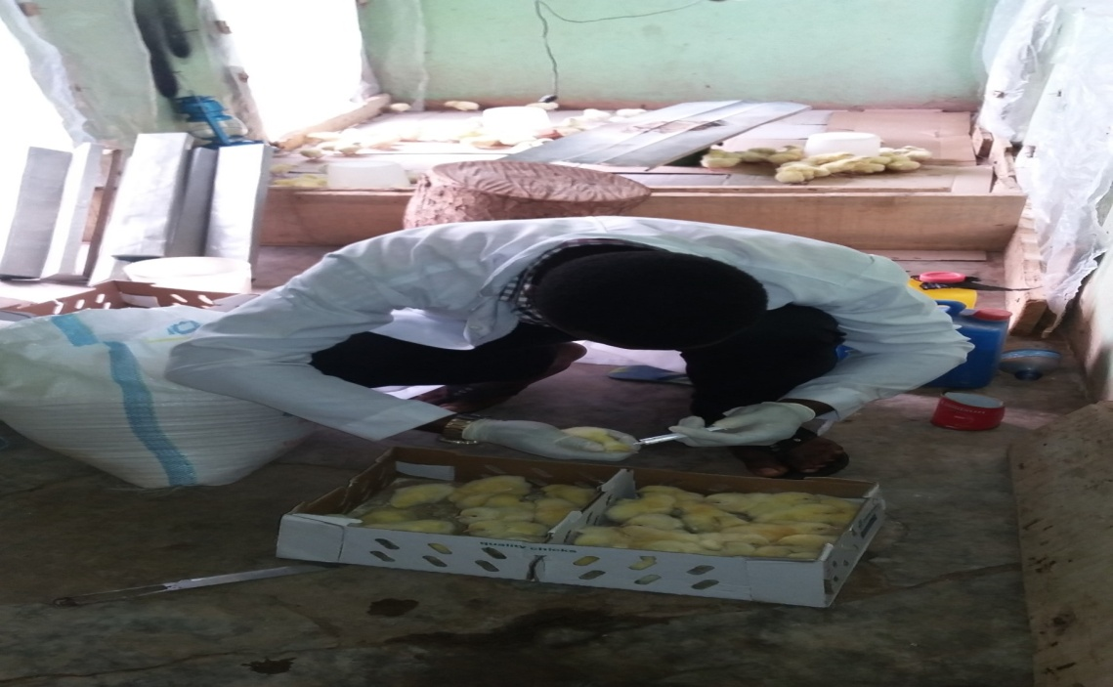
Plate 20: Vaccinating day old chicks
6.8 Diseases in Poultry
Disease refers to a state of ill health. It can also be defined as deviation from normal body function. It is caused by aetiological agent which include; viruses, bacteria, fungi, parasites, etc.
6.8.1 Viral Disease
- New Castle Disease
- Infectious Bursal Disease
- Infectious Bronchitis
- Avian Leukosis
- Morek’s Disease
- Fowl pox
In ANSCOAM farms, viral diseases that affected the poultry birds include;

- New Castle Disease
This is an acute viral disease of domestic poultry and many other bird species. It is caused by a paramyxovirus, of the group 1 serotype. Infection can result by aerosol and by ingesting contaminated water or feed. Signs include coughing, sneezing, paralyzed wings and legs, twisted necks, complete paralysis and some may die if not treated.
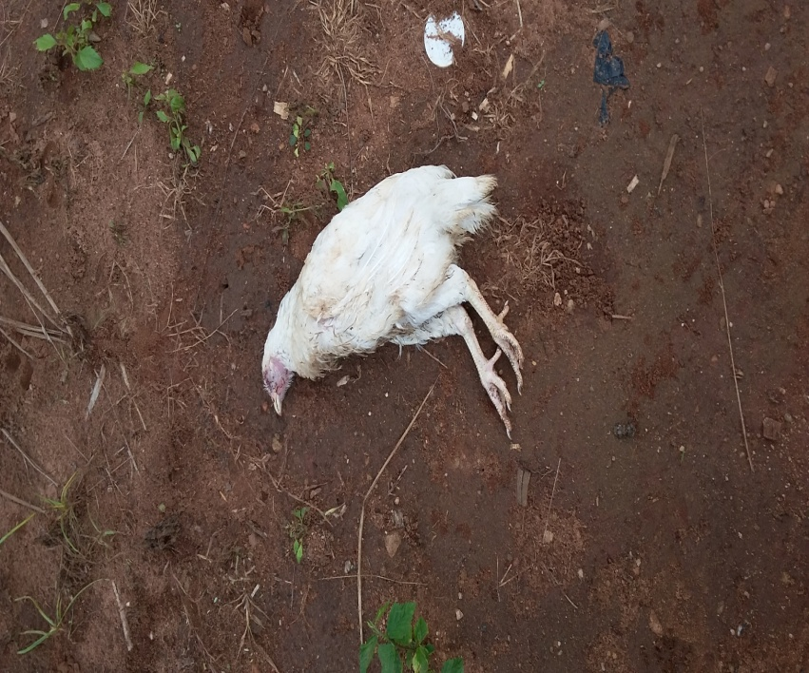
Plate 21: A bird affected with new castle disease
Treatment and Control: There is no effective treatment, however broad spectrum antibiotics can be administered to prevent secondary bacterial infection. In terms of control, vaccination at the appropriate age seems to be the best control method. High level of farm hygiene is also very important.
2. Infectious Bursal Disease (Gumboro disease)
This is a disease caused by infectious bursal disease virus (IBDV). It is a highly contagious viral disease of chicken.The virus can be shed in faeces of infected birds and transmitted from house to house by formites.
Treatment and control: Just as New castle disease, there is no known treatment for this disease but vaccination at the right time is really effective and might prevent the disease outbreak
6.8.2 Bacterial Disease
- Salmonelosis
- Fowl typhoid
- Fowl cholera
- Colibacillosis
- Chronic respiratory disease
- Infectious coryza
6.8.3 Myotic Diseases (fungi)
- Aspergillosis
- Mycotoxicoses
- Aflatoxicoses
6.8.4 Parasitic Disease
- Coccidiosis
- Helminthiasis
In ANSCOAM farm, coccidiosis is the only parasitic disease that affected the poultry.
Coccidiosis
This is a parasitic disease of the intestinal tract of fowl caused by a coccidian protozoa of the genus Eimeria. Eimeria necatrix and Eimeria tenella are the most pathogenic in chickens. Signs range from decreased growth rate to a high percentage of visibly sick birds, severe diarrhea and high mortality birds, weight loss, reduced water and feed intake, decreased egg production, etc

Treatment and Control: Treatment involves the use of coccidiostat and good management practice is the best way to control the disease outbreak

CHAPTER SEVEN
7.0 FARM RECORD KEEPING
Record keeping is one of the most important management practices of the farmer to know the state of the farm whether is making profit or loss
7.1 Importance of Farm record keeping
- It allows the farmer to improve in the business
- It assist the farmer to know how many workers to employ
- It shows the final position of the farmer
- It is good for making good estimation of the farm
- It is good in determining the price of the farm product such as (eggs, meat, fish, etc)
- It also helps to detect fraudulent practice of the workers at early stage

7.2 Formats of Farm Records
- Name of the farm
- Breed collected
- Source
- Date of collection
Table 4: Format of a farm record
Date | Total no. of Animals | Mortality | Balance | Remarks | Signature
 |  |  | The remaining animals are healthy
7.3 Vaccination/medication record
Breed …………………………………………..
Source………………………………………….
Date of Collection…………………………….

Table 5: Vaccination/medication record
Date | Age | Drug  Administered | Vaccine given | State of the animal | Remarks

7.4 Mortality Record
Source of the feeds ……………………………
Pen’s Number………………………………….
Attendants Name………………………………
Table 6: Mortality Feed record
Date | Age | Number of birds | Quantity of feed given | Remarks | Feed consumed | Remarks

Table 7: Daily egg collection record
Date | Age | No. of birds | 1st Collection | 2nd Collection | Total Collection | Number of Crack | Balance | Remarks

CONCLUSION AND RECOMMENDATION
The industrial training experience which lasted for six months was successful having been exposed on practical aspect of Zoology. The training has widened my scope of knowledge of different management practices such as poultry, piggery, rabbitry, fishery and rearing ruminant animals
With the experience I got during my course of training, I can proudly rear and manage livestock either in a commercial farm or a small scale domestic farm. All these can never be underestimated because it will serve as a future guide to my career as a Zoologist or as an Agriculturist in the Agricultural sector/industry

